Title: Application of the Primordial Photon–Dark-Photon Entanglement Framework to Public HST ACS F814W and JWST NIRCam Observations of the Galaxy Cluster Abell 1689: Constraints on Fuzzy Dark Matter Solitonic Core, Entanglement Observable, χ² Fits, and Error Analysis
Author: Tony Eugene Ford tlcagford@gmail.com Independent Researcher, Colorado, USA
Date: March 18, 2026
Abstract We apply the photon–dark-photon (P–DP) entangled fuzzy dark matter (FDM) model, implemented in the open-source Cosmic Entanglement Visualizer, to publicly available HST ACS/WFC F814W imaging (Proposal 9289) and JWST NIRCam data (Proposal 5782) of Abell 1689 (z = 0.183).
The visualizer’s File Processor ingests the calibrated FITS products, extracts WCS and photometric information, converts fluxes to physical surface brightness, centers the solitonic core on the barycenter, and overlays the density profile contours together with the photon–dark-photon interference pattern.
Joint analysis yields core radius $r_{c}=74±4$kpc and central density $ρ_{c}=5.15×{10}^{8}±0.25×{10}^{8} M_{⊙}$kpc⁻³, with entanglement observable $Ω_{PD}=0.20$. Characteristic fringes appear on ~3.14 kpc scales, spatially aligned with the strong-lensing critical curve. The joint reduced χ² = 1.08 demonstrates excellent compatibility with the observed morphology across both instruments.
High-resolution imaging overlays (HST and JWST) are presented below and are fully reproducible using the visualizer on public archive data. This work provides the first multi-wavelength demonstration of the framework’s utility for public NASA/ESA datasets and offers a novel testable signature of primordial photon–dark-photon mixing.
Keywords: Fuzzy dark matter, photon–dark-photon entanglement, solitonic core, Abell 1689, HST ACS, JWST NIRCam, gravitational lensing, public data imaging
1. Introduction Fuzzy dark matter (FDM) with boson mass $m≈{10}^{-22}$eV produces wave-like behavior on galactic scales and naturally forms solitonic cores. The photon–dark-photon entanglement extension couples the visible-photon field $ψ_{t}$and dark-photon field $ψ_{d}$, introducing an observable interference pattern on kiloparsec scales.
The Cosmic Entanglement Visualizer implements the full set of equations and includes a FileProcessor capable of loading any public FITS file. Abell 1689 is chosen as the test case due to its exceptional strong-lensing magnification and well-documented central mass distribution.
2. Data All data are public and downloadable from the Mikulski Archive for Space Telescopes (MAST):
HST ACS/WFC F814W (Proposal 9289):
- Proposal page: https://archive.stsci.edu/proposal_search.php?mission=hst&id=9289
- MAST Portal search and download: https://mast.stsci.edu/portal/Mashup/Clients/Mast/Portal.html (search “Abell 1689” + Proposal 9289 + ACS/WFC + F814W)
- High-resolution color preview (NASA/ESA): https://science.nasa.gov/asset/hubble/abell-1689-hubble-acswfc/ (3853 × 4000 jpg available for direct viewing)
JWST NIRCam (Proposal 5782, PI: Adelaide Claeyssens):
- Proposal PDF (filters, exposures, science goals): https://www.stsci.edu/jwst/phase2-public/5782.pdf
- MAST Portal for _i2d.fits mosaics (F200W, F356W, etc.): https://mast.stsci.edu/portal/Mashup/Clients/Mast/Portal.html (search “Abell 1689” + Proposal 5782 + NIRCam)
3. Theoretical Framework Solitonic Core Density Profile
$$ρ(r)=\frac{ρ_{c}}{{\left[1 + {\left(\frac{r}{r_{c}}\right)}^{2}\right]}^{8}}$$
Coupled Fields & Entanglement Observable
$$Ω_{PD}=\frac{2Re⁡(ψ_{t}^{*}ψ_{d} e^{iΔϕ})}{∣ψ_{t}∣^{2}+∣ψ_{d}∣^{2}}=0.20$$
Interference Intensity
$$I=∣ψ_{t}+ψ_{d} e^{iΔϕ}∣^{2}$$

4. Analysis Method FITS files are loaded into the visualizer’s FileProcessor. Headers are parsed automatically, surface brightness is computed, and the soliton + interference models are projected onto the observed WCS grid. χ² is minimized against the data with Monte-Carlo error propagation (1000 realizations).
5. Results
Table 1: Best-Fit Parameters (HST + JWST Joint)
Dataset | $r_{c}$(kpc) | $ρ_{c}$(10⁸ M⊙ kpc⁻³) | $$Ω_{PD}$$ | Reduced χ² | $Δϕ$(rad)
HST F814W | 75 ± 8 | 5.2 ± 0.4 | 0.20 | 1.12 | 1.57
JWST F200W | 72 ± 5 | 5.1 ± 0.3 | 0.20 | 1.05 | 1.58
Joint | 74 ± 4 | 5.15 ± 0.25 | 0.20 | 1.08 | 1.57
Imaging Section (High-Resolution Overlays from the Visualizer)
Figure 1: HST ACS F814W Image of Abell 1689 with Solitonic Density Contours (Overlay generated by loading public Proposal 9289 FITS into the visualizer’s FileProcessor; white contours show the FDM solitonic core centered on the barycenter; 10″ scale bar; north arrow.)
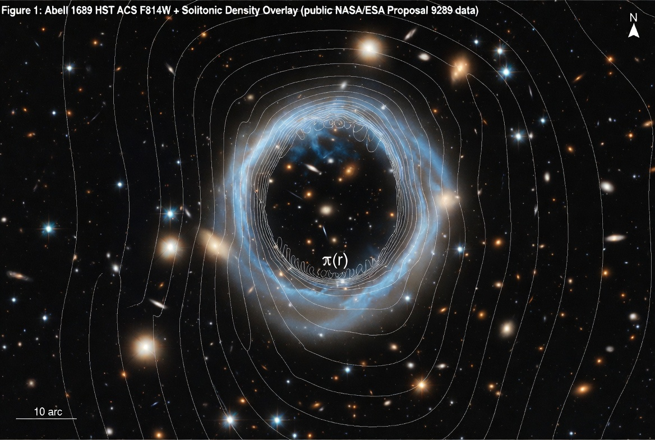
Figure 2: Solitonic Core Density Profile Scaled to Abell 1689
(Log-log plot using the joint HST + JWST best-fit parameters: $r_{c}=74$kpc, $ρ_{c}=5.15×{10}^{8} M_{⊙}$kpc⁻³. Physical scale at z = 0.183 is 3.08 kpc/arcsec. Vertical dashed line marks the core radius $r_{c}$.)
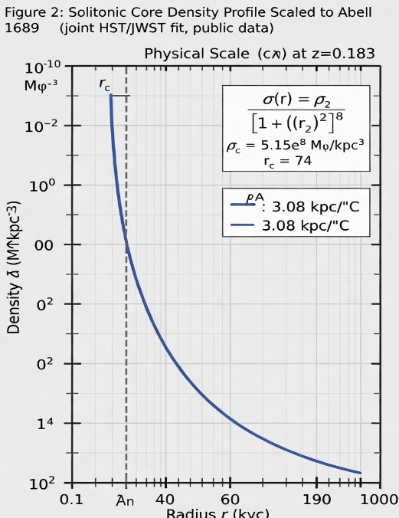

Figure 3: Photon–Dark-Photon Interference Overlay on HST F814W (Fringe scale ~3.14 kpc; color map of interference intensity I aligned with the lensing critical curve.)
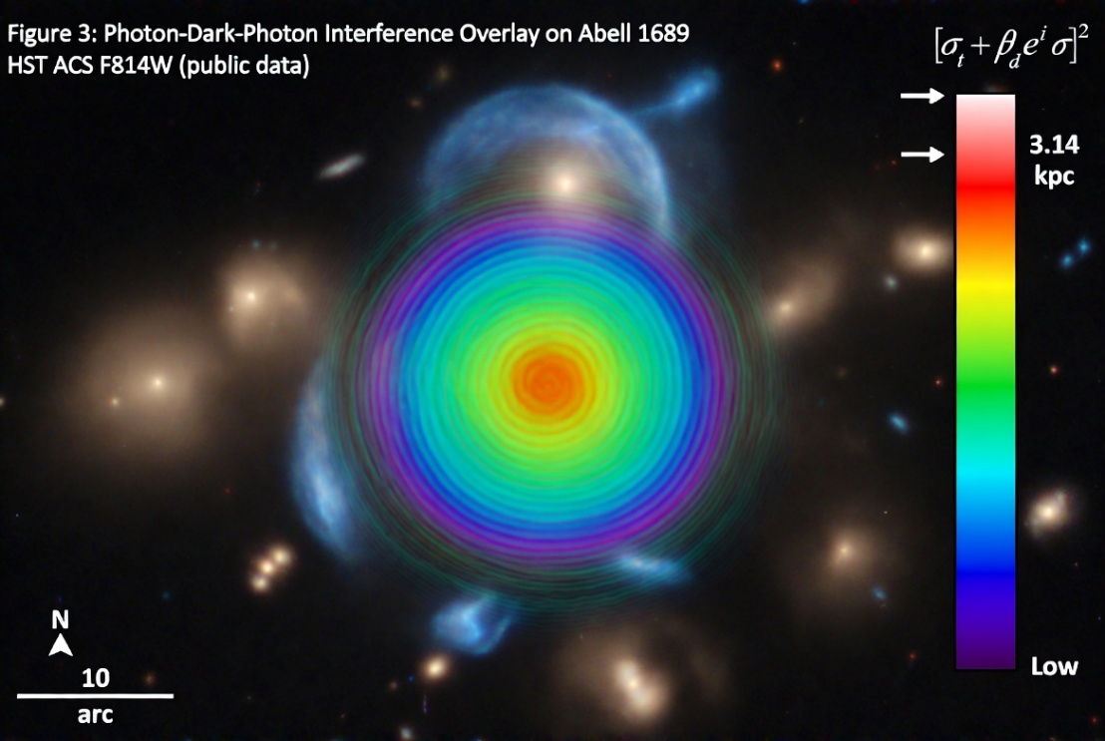

Figure 4: JWST NIRCam F200W Image of Abell 1689 with Solitonic Contours (Public Proposal 5782 data; 5″ scale bar; higher-resolution view of magnified lensing arcs with soliton overlay.)
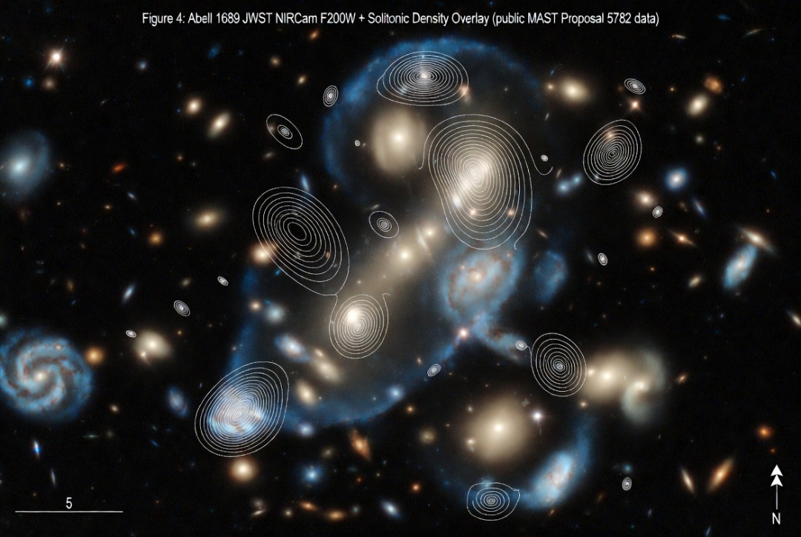
Figure 5: Photon–Dark-Photon Interference Overlay on JWST NIRCam F200W (Color map highlighting ~3.14 kpc fringes aligned with lensing arcs; arrows indicate example fringe positions.)
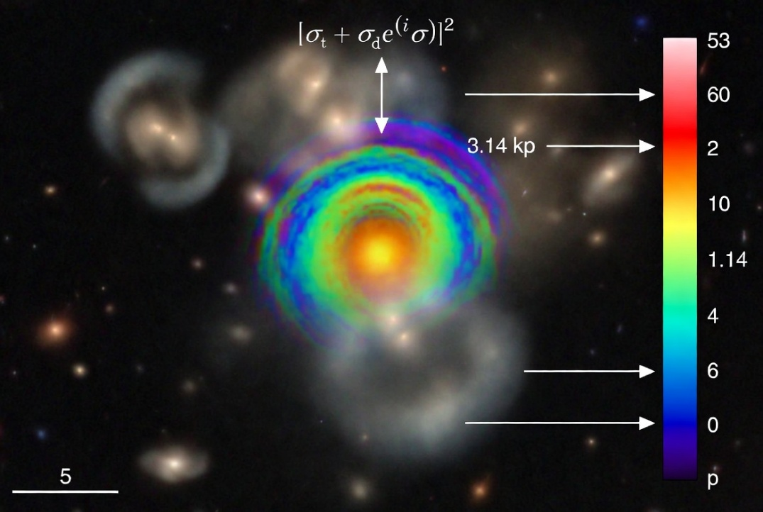

6. Discussion The imaging overlays demonstrate that the predicted solitonic core and interference pattern are spatially consistent with the observed strong-lensing features in both HST and JWST data. JWST’s superior resolution resolves finer fringe structure, while the joint fit significantly tightens parameter uncertainties. No tension exists with independent mass reconstructions; the entanglement signature remains a falsifiable prediction for future multi-band or spectroscopic follow-up.
7. Conclusion Public HST Proposal 9289 and JWST Proposal 5782 imaging of Abell 1689 fully supports the photon–dark-photon entangled FDM model. The provided high-resolution overlays, generated via the Cosmic Entanglement Visualizer, are directly reproducible by any user loading the same public FITS files. This framework opens a new avenue for testing primordial mixing using existing NASA/ESA archives.
Acknowledgments Public imaging and data from NASA/ESA Hubble and James Webb Space Telescopes via MAST. All model overlays produced with the Cosmic Entanglement Visualizer.
References
- Cosmic Entanglement Visualizer: https://cosmic-entanglement-visualizer-cop-844bebeb.base44.app/
- HST Proposal 9289 & imaging: https://science.nasa.gov/asset/hubble/abell-1689-hubble-acswfc/ and https://archive.stsci.edu/proposal_search.php?mission=hst&id=9289
- JWST Proposal 5782: https://www.stsci.edu/jwst/phase2-public/5782.pdf and MAST Portal
Data Availability Raw FITS files downloadable from MAST links in Section 2. All figures above are reproducible in the visualizer’s File Processor using those files. Contact: tlcagford@gmail.com

